附件2、会议地点、酒店及交通
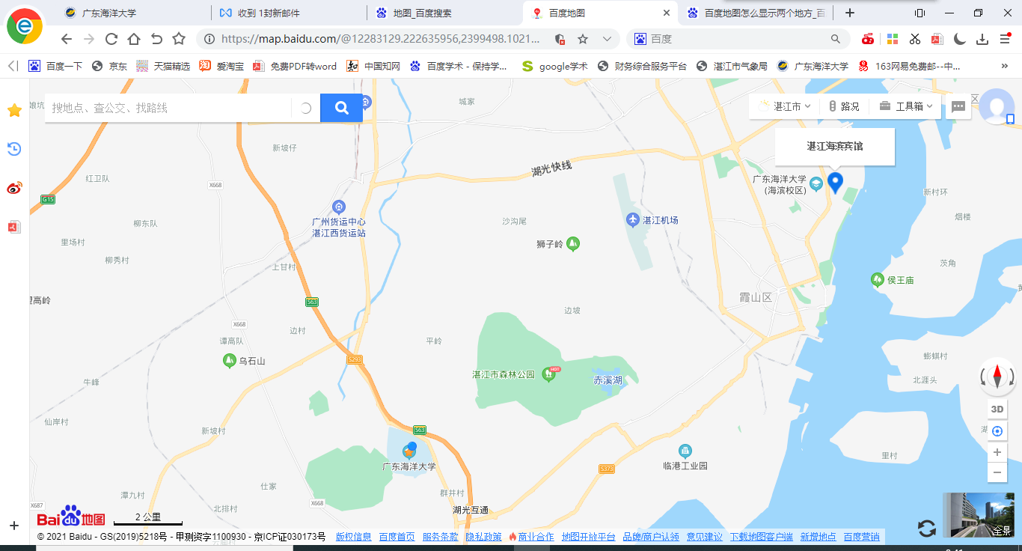
会议地址：广东省湛江市麻章区海大路1号海洋与气象学院
会议住宿：湛江海滨宾馆（广东省湛江市霞山区海滨大道中2号）
交通线路一：湛江机场---湛江海滨宾馆
线路一：乘坐出租车，费用约30元；
路线二：从湛江机场步行92米，在湛江机场站乘坐机场专线公交车（海田公交站方向），农垦医院公交站下车，步行477米，在鼎盛广场公交站（乾塘客运站方向）乘坐911路公交车，在荣基国际广场站下车，步行347米至酒店，全程大约1小时。

交通线路二：湛江西站---湛江海滨宾馆
线路一：乘坐出租车，费用约60元；
路线二：从湛江西站步行161米，在铁路西客站乘坐65k路公交车（海滨公园北门方向），在荣基国际广场站下车，步行330米至酒店，全程大约1小时。

Attachment 2、Hotel Location and Transportation
Zhanjiang Haibin Hotel
Transportation Line 1: Zhanjiang Airport- -Zhanjiang Haibin Hotel
Line 1: Take a taxi, the cost is about ¥30;
Line 2: Walk 92 meters from Zhanjiang Airport, take Airport bus (direction of Haitian bus station) at airport Station, get off at “农垦医院” Bus Station, walk 477 meters, take No.911bus in “鼎盛广场” (direction of “乾塘” bus station), and get off at the “荣基国际广场”bus station. The whole journey is about 1 hours.

Transportation Line 2: Zhanjiangxi Railway Station- -Zhanjiang Haibin Hotel
Line 1: Take a taxi, the cost is about ¥60 ;
Line 2: Walk 161 meters from Zhanjiangxi Railway Station take No.65K bus (direction of海滨公园北门) , get off at “荣基国际广场” Bus Station, The whole journey is about 1 hours.

